**Introduction to Database Foundations with NoSQL**

# Hands On 1 & Hands On 2 (optional)

For your first Hands On in NoSQL, practice inserting a document into your appusers collection. You can include whatever fields you would like. Check on mlab once the query is run to see if your document now exists in your collection.

Create three more users of your choosing

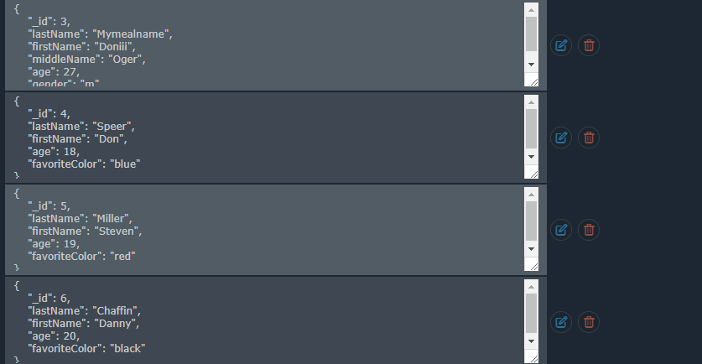

# Hands On 3 (optional)

db.cars.insertMany([{make: "Chevy", model: "Volt", color: "velvet", year: 2018, fourDoor: true, fourWheelDrive: false},

{make: "Ford", model: "Ranger", color: "white", year: 1999, fourDoor: false, fourWheelDrive: true},

{make: "Toyota", model: "Tacoma", color: "white", year: 2018, fourDoor: true, fourWheelDrive: true},

{make: "Tesla", model: "Roadster", color: "smokey grey", year: 2018, fourDoor: false, fourWheelDrive: false},

{make: "Toyota", model: "4-Runner", color: "white", year: 2020, fourDoor: true, fourWheelDrive: true}])

db.cars.find({})

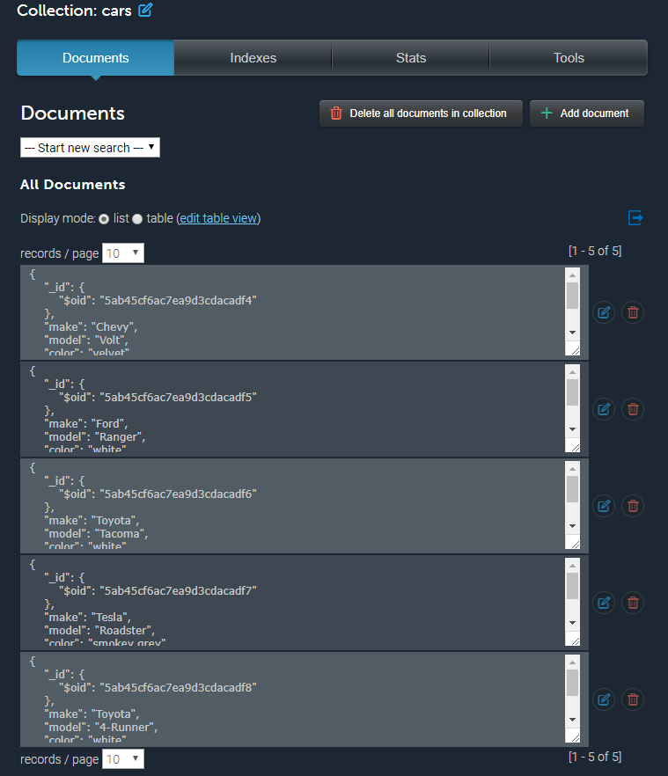

# Finding Documents

**Hands On 1**

* Find all movies that are longer than 2 hours
* Find all movies that do not have Tom Hanks as a lead actor
* Find all movies that were directed by Christopher Nolan

db.movies.find( { lengthInMin: { $gt : 120} } )

db.movies.find( {director: { $ne: "Tom Hanks" } } )

db.movies.find( {director: "Christopher Nolan"} )

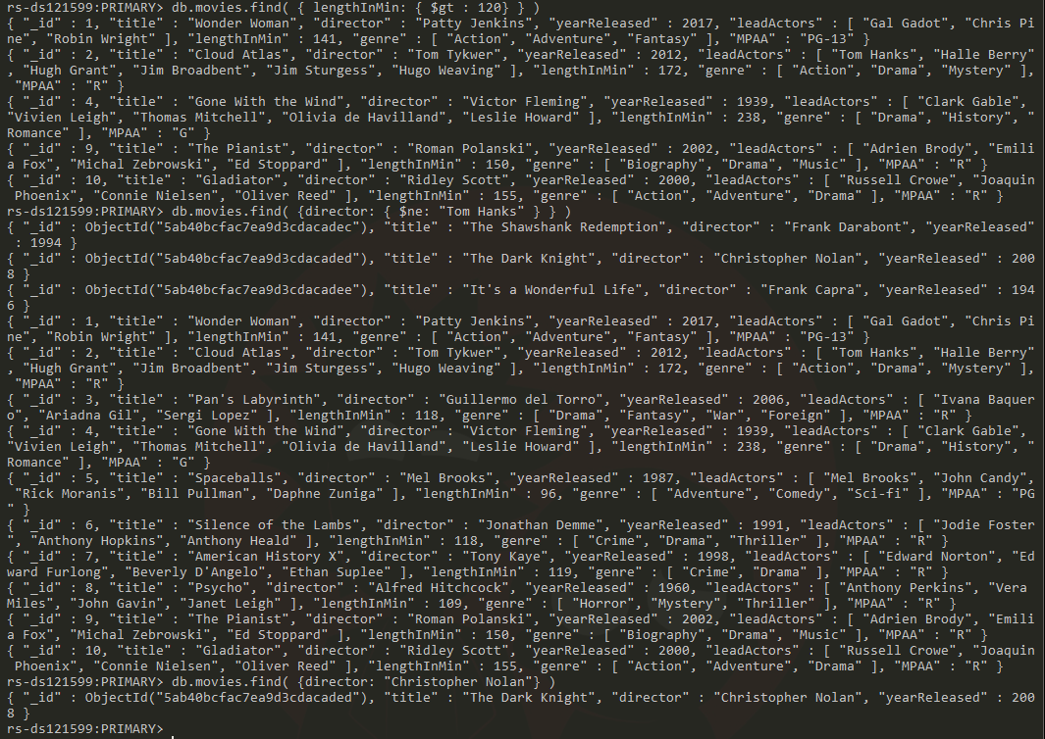

**Hands On 2 (optional)**

* Find all movies that are not considered Drama
* Find all movies that are longer than 90 minutes but less than 2 hours
* Find all movies that are considered Action or Adventure and return only the title of the movie

db.movies.find( {genre: {$exists: false, $nin: [ "Drama" ]} })

db.movies.find({ $and: [ { lengthInMin: { $gt: 90 } }, { lengthInMin: { $lt: 120 } } ] })

db.movies.find({$or:[{ genre : "Action" }, { genre : "Adventure" }]}, {title: 1})

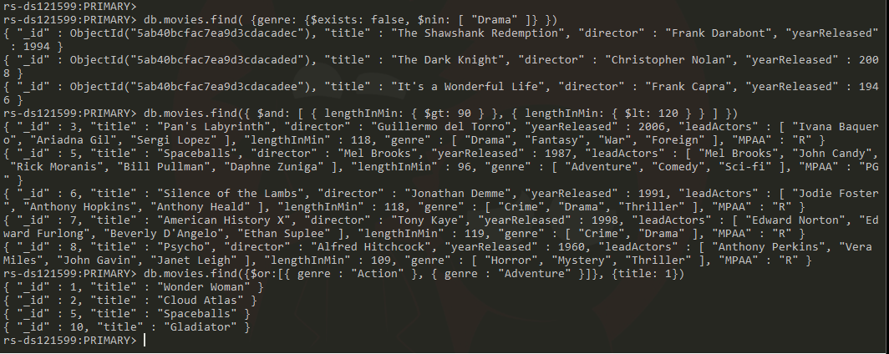

# Hands On 3

"Sally has very poor eyesight so cannot watch any foreign films. Robert absolutely hates Jodie Foster and refuses to watch any movies with her in it. Stewart has somewhere to be after movie night so can't watch a movie longer than 2 hours.",

db.movies.find( {$and: [ { genre: {$ne: "Foreign"} },{ leadActors: {$ne: "Jodie Foster"} },{ lengthInMin: { $lt: 120} } ] } )

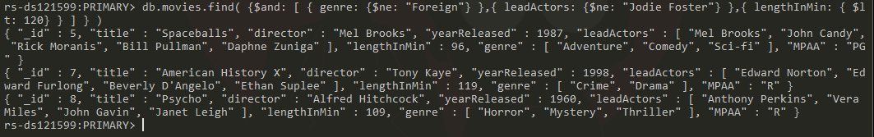

**Hands On 1**

* Update the item of "journal" to have a height of 16.
* Update all items with a status of "D" to have a quantity of 50.
* Update the item "paper" to include a field "rating" that has the value of "4 stars" and change its status to "A".

db.inventory.update( { "item": "journal"}, { $inc: { "size.h": +2 } } )

db.inventory.updateMany( {"status": "D"}, { $set : {"quantity": 50 } }, {upsert : true} )

db.inventory.updateOne( {"item": "paper"}, { $set: {"rating": "4 stars", "status": "A"}}, { upsert : true})

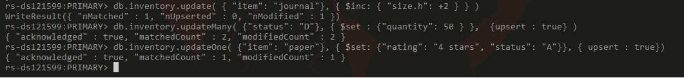

**Hands On 2 (optional)**

* Update all items to change the "h" and "w" fields to be "height" and "width".
* Update the item notebook so that the "height" and "width" is incremented by 2.
* Update all items that have a "quantity" less than 80 to be updated to have that same number.
* Update the items paper and planner to multiply the "height" by 3.

db.inventory.updateMany({}, { $rename: { "size.h" : "size.height" } } )

db.inventory.updateMany({}, { $rename: { "size.w" : "size.width" } } )

db.inventory.update( { "item": "notebook"}, { $inc: { "size.height": +2 } } )

db.inventory.update( { "item": "notebook"}, { $inc: { "size.width": +2 } } )

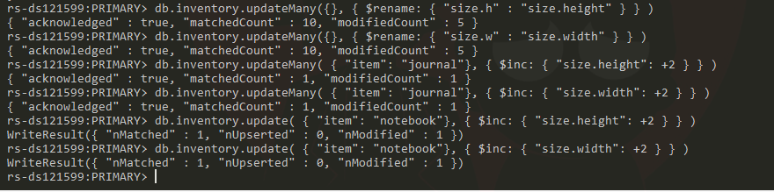

# Hands On 3 (optional)

The company you are working for wants to update their inventory database. Currently, there are 10 pieces of inventory in the database. They want to give each product a rating of 4 stars to start, as well as a field that notes if it has been rated yet using a boolean. They would like this to be reflected in the database as "rating" with two fields: "numberOfStars" and "hasBeenRated". Also, they are wanting to double the quantity of every product since the company is growing rapidly. Lastly, they would like you to find all products that are sized using centimeters and give them a status of "B".

# Deleting Documents & Indexes

**Hands On 1**

Start off by deleting the entire collection "cars".

Before:

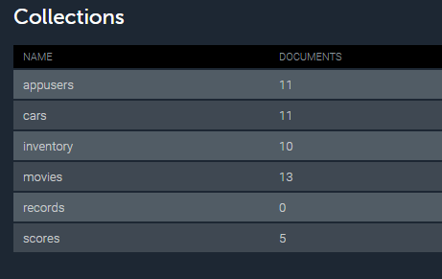

After: db.cars.drop()



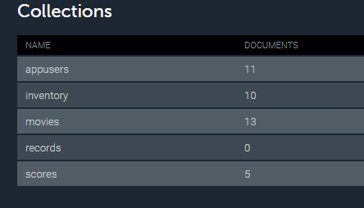

Create an index on the price field for the "cars" collection.

db.cars.createIndex( { price: 1 } )

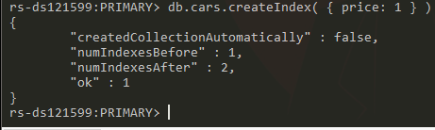

**Hands On 2 (optional)**

Create an index on documents that are not used cars.

## **Part 1 Final**

You have just been hired at a startup company. They currently only have 10 employees, but they need to be included into the database. So far, they have only been tracked within an excel sheet. Your boss would like you to create a new collection in mlab named "employees". Take a look at the following data and the notes listed below before inserting any data:

* The Date field should have a data type of Date.
* The Position Name, Remote, and Full Time fields should be within an embedded document called "position".
* Remote and Full Time fields should have boolean values.

db.employees.insertMany([

{name: "Alison Davidson",

birthday: Date("1975-04-05"),

address: "874 W. Oak Place",

city: "Gary",

state: "Indiana",

position: {"position name": "Customer Support", remote: true, "full time": true}},

{name: "Henry Chapelton",

birthday: Date("1980-09-29"),

address: "9324 E. Vista Way",

city: "Tempe",

state: "Arizona",

position: {"position name": "Customer Support", remote: false, "full time": true}},

{name: "Alex Miller",

birthday: Date("1983-11-22"),

address: "244 Price Road",

city: "Mesa",

state: "Arizona",

position: {"position name": "Customer Support", remote: false, "full time": false}},

{name: "Carly Nielson",

birthday: Date("1987-08-04"),

address: "678 W. Westward Road",

city: "Phoenix",

state: "Arizona",

position: {"position name": "Office Manager", remote: false, "full time": true}},

{name: "Tom Talbot",

birthday: Date("1989-12-30"),

address: "12 Oakland Way",

city: "Chandler",

state: "Arizona",

position: {"position name": "Inventory Manager", remote: false, "full time": true}},

{name: "Mary Crawley",

birthday: Date("1980-07-06"),

address: "1010 Granite Way",

city: "Charlotte",

state: "North Carolina",

position: {"position name": "Human Resources", remote: true, "full time": true}},

{name: "Daisy Baster",

birthday: Date("1987-09-09"),

address: "990 E. 84th St.",

city: "Tempe",

state: "Arizona",

position: {"position name": "CEO", remote: false, "full time": true}},

{name: "William Coyle",

birthday: Date("1991-10-11"),

address: "944 W. 16th St.",

city: "Phoenix",

state: "Arizona",

position: {"position name": "Intern", remote: false, "full time": false}},

{name: "Edith Bates",

birthday: Date("1990-07-28"),

address: "7 E. 20th Pl.",

city: "Chandler",

state: "Arizona",

position: {"position name": "Customer Support", remote: false, "full time": true}},

{name: "Gwen Harding",

birthday: Date("1986-10-11"),

address: "234 W. 48th. St.",

city: "Phoenix",

state: "Arizona",

position: {"position name": "Office Assistent", remote: false, "full time": true}}

])

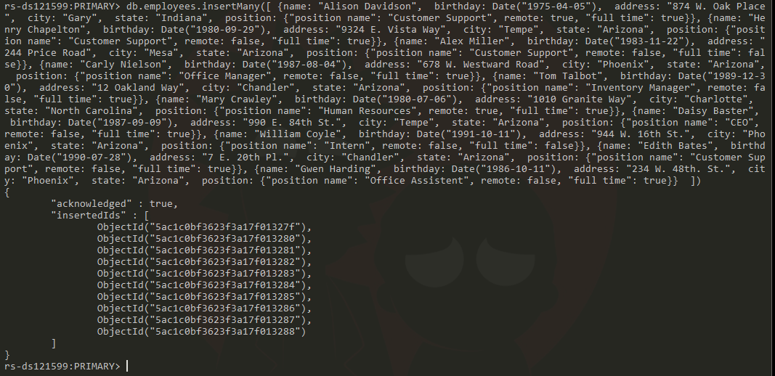

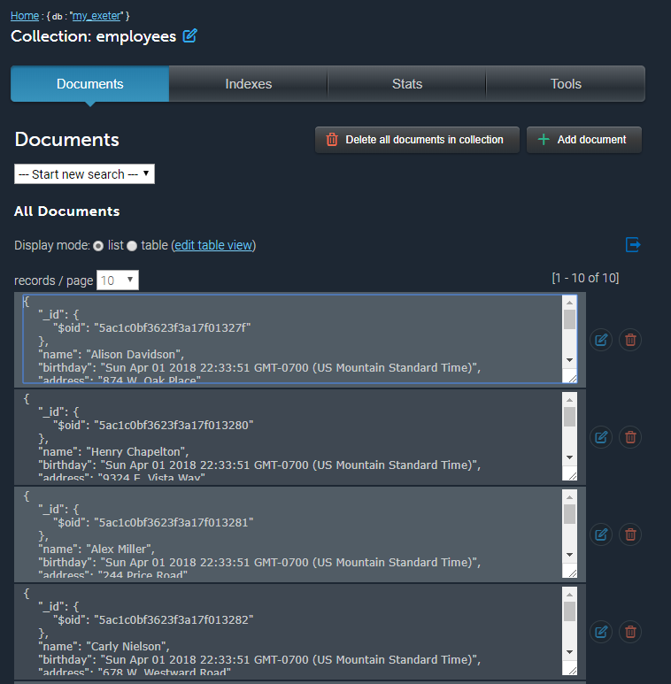

## **Part 2**

It's been about a month since you have inserted all employees into the database. There have been a couple of changes to the company. The CEO decided that he no longer wants remote employees, so they have transferred the remote employees to now live in Arizona. Alison Davidson now lives at 777 E. 1st St. # 120 Tempe, AZ and Mary Crawley now lives at 8322 W. Vista Pl. Scottsdale, AZ. Since all employees now all live in Arizona, there is no need to have a field named "state" within this collection, so please remove it. Lastly, they would like very efficient searching using the "position" field (remember that field includes a document with 3 other fields).

db.employees.updateOne( {"name": "Alison Davidson"}, { $set: {"address": "777 E. 1st St. # 120 ", "city": "Tempe", "state": "Arizona", "position.remote": false}}, { upsert : true})



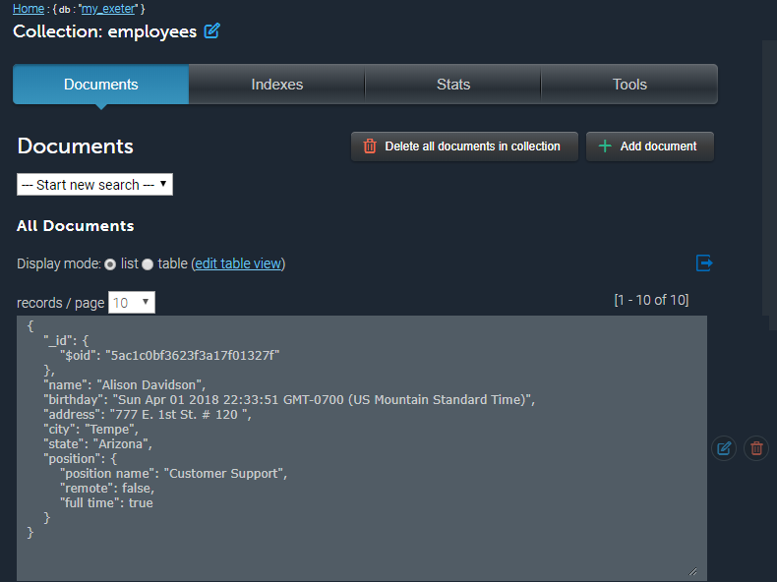

db.employees.updateOne( {"name": "Mary Crawley"}, { $set: {"address": "8322 W. Vista Pl.", "city": "Scottsdale", "state": "Arizona", "position.remote": false}}, { upsert : true})



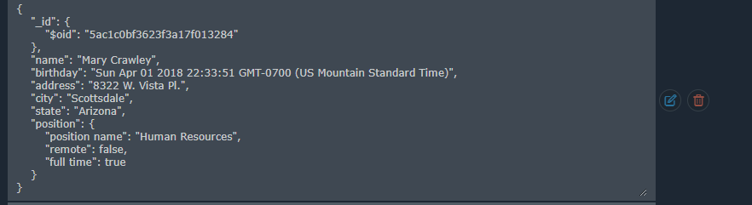

db.employees.updateMany( {}, {$unset: {"state": ""} } )

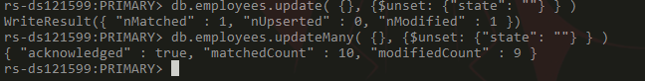

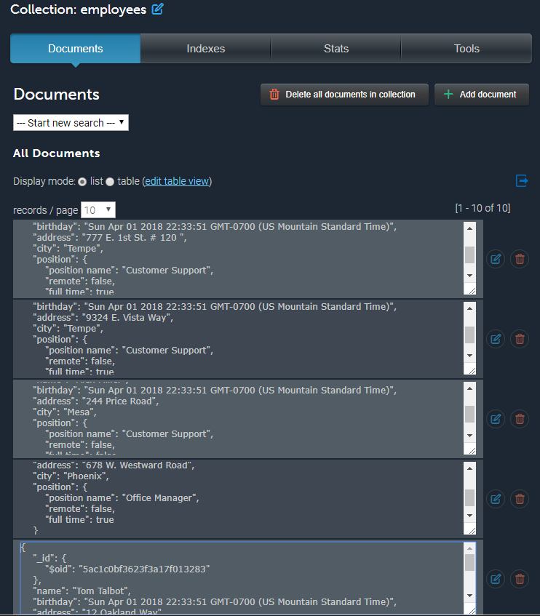

db.employees.updateMany({}, { $rename: { "position.position name" : "position.name" } } )

db.employees.updateMany({}, { $rename: { "position.full time" : "position.fulltime" } } )



db.employees.createIndex( { "position.name": 1 } )

db.employees.createIndex( { "position.remote": 1 } )

db.employees.createIndex( { "position.fulltime": 1 } )

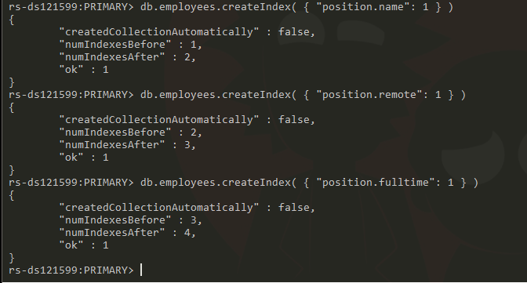

**Optional Project**

**Part 1**

Please insert this data into a new collection named "songs".